Opening of the first permanently installed clean room at the FAULHABER location in Schönaich (Germany)
New possibilities for the production of drives for medical technology
On September 13, the new clean room at the FAULHABER main location was unveiled and presented in the presence of the management board as well as those responsible for the project. The production area measuring 90 m² will in future be used to manufacture products for medical technology and the pharmaceutical industry under special conditions. Production in the clean room will begin in the middle of next year.
The medical technology market is continuously shaped by new trends and also poses particular challenges in terms of the quality and purity of the used drives. To expand the production capacity of drive systems intended for this industry in the future, FAULHABER has installed and recently unveiled a new clean room at its main location. The drives which will be manufactured there from 2024 meet the special requirements of the medical industry and can be used in many different areas of medical technology and the pharmaceutical industry.
The new clean room measures 125 m², 90 m² of which is purely for production, surrounded by airlocks for personnel and material to ensure that clean room conditions are maintained. "Our clean room will be certified to ISO class 7; in other words, the permissible concentration of indoor air particulates is restricted and microbiological contamination of the air is limited," explains Andreas Melzer, head of the Safety, Facility & Maintenance department at FAULHABER. This is ensured by an air exchange rate of 25 times every hour, which means that the room air is replaced completely about every two and a half minutes. Comparison with air exchange rates of three to four times per hour in other areas of production where there are no clean room conditions illustrates the performance of the ventilation system for the new clean room.
The new production area took seven months to complete. The construction work was carried out behind a dust protection wall so as not to affect ongoing production. Opening of the new clean room took place on September 13, 2023, in the presence of the project team as well as the managing directors Lutz Braun, Dr. Udo Haberland and Hubert Renner.
For FAULHABER, the newly constructed area means an increase in its clean room capacity – the location at Schönaich has had a clean room tent for products from the semiconductor industry since 2021. "Nevertheless, the first permanently installed clean room at the location is something completely new and extremely exciting for us," says Melzer. Commissioning is scheduled for the middle of 2024 when there will be permanent staff made up of FAULHABER employees who will be trained and equipped for work in the clean room and will be active primarily in the new facility. Until then, there are a number of work steps that still need to be completed, such as fitting out the room with workstations and equipment as well as the connection of the cleaning system to the material lock. This ensures that all components used satisfy the clean room requirements.
Thanks to the modular structure of the new FAULHABER clean room, a further expansion of production capacity in this area will be possible in the future.
 | 456 words / 3.310 characters
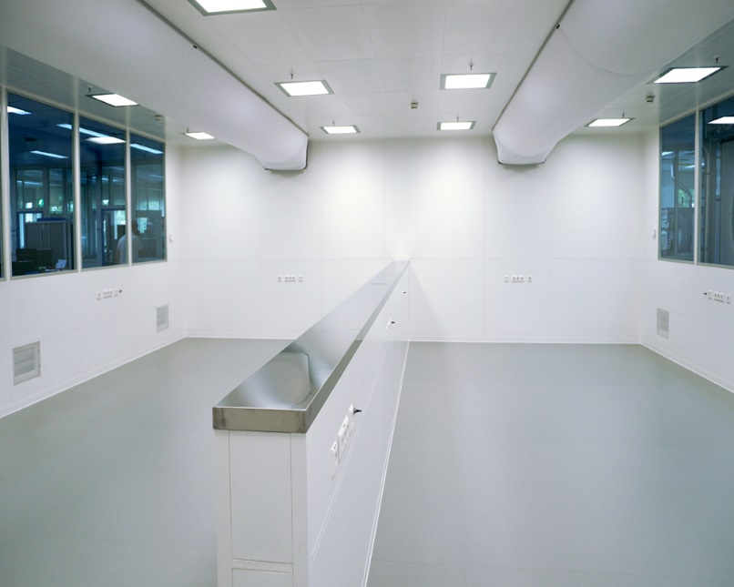 | Opening of the first permanently installed clean room at the FAULHABER location in Schönaich (Germany) © FAULHABER

Press contact (Germany + International)  Dr. Fritz Faulhaber GmbH & Co. KG  Kristina Wolff – Marketing  Faulhaberstraße 1 · 71101 Schönaich  Germany  T +49 7031 638-148 · F +49 7031 638-8148  redaktion@faulhaber.com | Press contact (Switzerland)  FAULHABER SA  Ann-Kristin Hage-Ripamonti – Marketing  6980 Croglio  Switzerland  T +41 91 61 13 239 · F +41 91 611 31 10  marketing@faulhaber.ch

