Linear Actuator FAULHABER L product family

High performance in compact dimensions

Schönaich. With the all-new Linear Actuator L product family, FAULHABER is offering a unique turn-key-solution for a broad range of applications. The smaller versions 06L/08L/10L are ideal for medical, lab automation, optics & photonics or space applications. The larger versions 22L/32L using the latest GPT gear technology, are designed for applications in the industrial automation and also optics & photonics. The linear actuator FAULHABER L family can therefore be combined with a wide range of DC motors, 4-pole and 2-pole brushless motors or stepper motors and are optimized to leverage at best the torque and speed range of the different FAULHABER motor families.

The unique Linear Actuator FAULHABER L product family is designed for high performances in compact dimensions, it supports large input speed or high output force. It is well-suited for a wide range of applications like robotics, industrial machines and laboratory equipment. A large number of reduction ratios, uniformly distributed, are available to select the most appropriate configuration to fit various force or speed operating points as required by the application. This new family also grants high flexibility offering different screw sizes and types; moreover a large selection of options are available to match different ambient conditions and make mechanical integration inside applications faster and smoother through various flange and nut configurations.

Additional, the new FAULHABER L family offers a very robust design. It is met by a wide portfolio of combinable motors such as FAULHABER DC motors, 4-pole and 2-pole brushless motors or stepper motors. As always, customer specific modifications are also possible. Some of these meet particular requirements with special ambient conditions, others ease the product integration into the application system or enhance particular performance parameters to fulfil specific needs, like accuracy.

Product options can refer to the coupler, to the screw or both, for example:
- screw type and length;
- nut type and length;
- ambient conditions like particular temperature range or
special environmental conditions as vacuum;
- different motor cable or terminals orientation when integrating the combination unit inside the application.

Each of the available screw types has its own characteristics that should be taken into account to find the best match with specific needs. The basic difference between ball and lead screws is rolling movement of the ball screw nut, which eliminates the sliding friction typical of lead screws, resulting in a very high efficiency. The smaller FAULHABER L series 06L/08L/10L are equipped with lead screws in two load characteristics. The larger 22L and 32L series are available with lead screws and additionally as ball screw versions in two accuracy options.

2.878 Characters
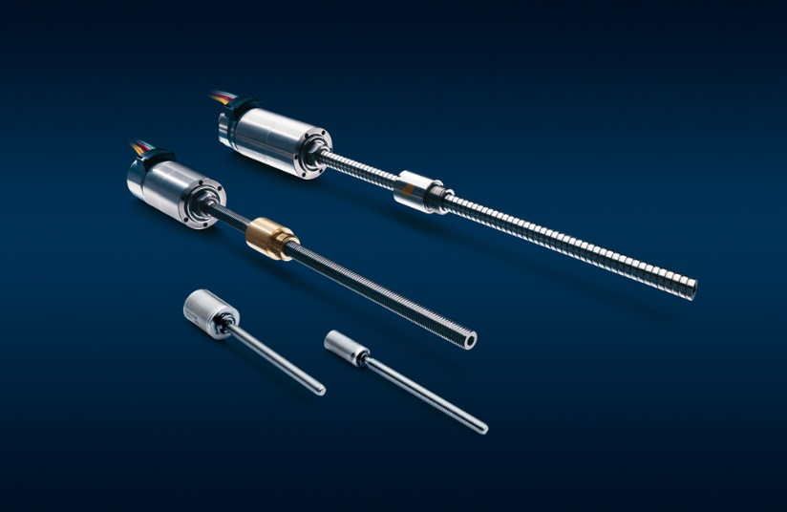
Linear Actuator L product family. © FAULHABER

https://www.faulhaber.com/en/products/linear-actuators/geared-linear-actuators/

Press contact (Germany + International)  Dr. Fritz Faulhaber GmbH & Co. KG  Kristina Wolff – Marketing  Faulhaberstraße 1 · 71101 Schönaich  Germany  T +49 7031 638-148 · F +49 7031 638-8148  redaktion@faulhaber.com | Press contact (Switzerland)  FAULHABER MINIMOTOR SA  Ann-Kristin Hage-Ripamonti – Marketing  6980 Croglio  Switzerland  T +41 91 61 13 239 · F +41 91 611 31 10  marketing@faulhaber.ch

