Schönaich, April 1, 2022

FAULHABER integrates subsidiary PDT
Greater added value, shorter reaction times, more competence
Even in the year of the company's 75th anniversary, FAULHABER continues to improve customer service. Effective April 1, 2022, Dr. Fritz Faulhaber GmbH integrates subsidiary PDT Präzisionsdrehteile GmbH from Nürtingen and thereby welcomes 34 new specialists to the Schönaich location. Thanks to this strategically planned step, FAULHABER can, with a machining center of its own, respond more quickly to individual requests and expands competencies in the area of machining production.

PDT has been a subsidiary of FAULHABER since 2014 and, since this time, has produced turned parts for the drive systems of the renowned specialist for miniature and micro drive technology. "The integration is part of our growth strategy, to further expand our own delivery capability and increase the added value for our customers," explains Karl Faulhaber, Managing Director at FAULHABER. "We now have our own high-performance machining center in-house," Faulhaber is pleased to note. "This allows us to make a wider range of customer-specific modifications and to do so more quickly, thereby reducing delivery times for our customers, and optimally complements the synchronization of our production locations."

The CNC machinery has already been relocated to Schönaich. The new specialists are pleased to now be part of the renowned FAULHABER company and are working in three-shift operation at the new location. "We are happy about our new colleagues and wish them a good start in Schönaich," says Faulhaber. "With this change, we are expanding our competencies in this area as well in a targeted manner. Our customers also benefit from this – with an even wider selection of individual, complete drive solutions."

About the company
FAULHABER is an independent, family-run group of companies headquartered in Schönaich near Stuttgart, Baden-Württemberg. Founded in 1947, FAULHABER today boasts the largest range of highly developed miniature and micro drive technology which is available worldwide from a single source.
Using this wide variety of technologies, the company designs drive solutions that are unrivalled when it comes to precision and reliability in very small spaces. The main areas of use include production automation and robotics, aerospace, optical systems as well as medicine and laboratory technology.
In addition to Germany, FAULHABER maintains development and production locations in Switzerland, USA, Romania and Hungary. Moreover, there are sales partners and subsidiaries in more than 30 countries around the world.
 | 391 words / 2,616 characters
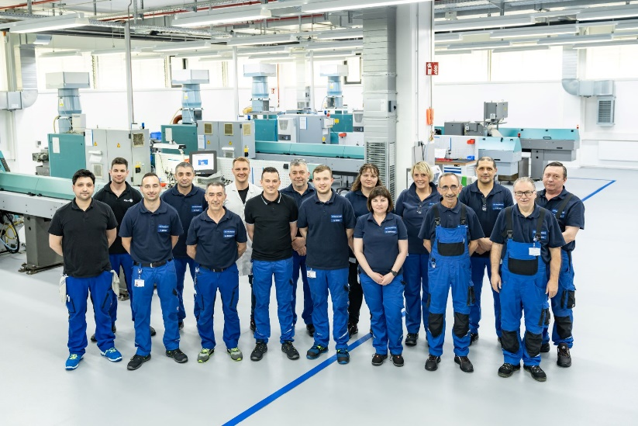 | [Image]  Subsidiary PDT Präzisionsdrehteile GmbH  © FAULHABER

Press contact (Germany + International)  Dr. Fritz Faulhaber GmbH & Co. KG  Kristina Wolff – Marketing  Daimlerstraße 23/25 · 71101 Schönaich  Germany  T +49 7031 638-148 · F +49 7031 638-8148  redaktion@faulhaber.com | Press contact (Switzerland)  FAULHABER MINIMOTOR SA  Ann-Kristin Hage-Ripamonti – Marketing  6980 Croglio  Switzerland  T +41 91 61 13 239 · F +41 91 611 31 10  marketing@faulhaber.ch

