New FAULHABER IEP3 incremental encoder
Impressive accuracy through the latest chip technology
Schönaich – With the launch of the IEP3, FAULHABER expands its product line with an incremental encoder which, thanks to the latest chip technology, achieves a very high resolution and accuracy. With a diameter of just 8 mm, the IEP3 is very lightweight and compact yet still offers a resolution of up to 10,000 lines per revolution – made possible by the latest chip technology with high interpolation. In the standard version, the resolution is freely programmable from 1 - 4,096 lines per revolution. Moreover, the chip technology that is used ensures a high positional accuracy of typically 0.3 °m as well as a high repeatability of typically 0.05 °m thanks to accuracy compensation.

The IEP3 can be powered with a supply voltage of both 5 V and 3.3 V. This makes it suitable for use in battery-powered applications as well, which are typically operated with 3.3 V. A wide temperature range of -40 to + 125 °C likewise opens the door for various possible uses. The IEP3 is suitable for a wide array of applications and is characterized by high accuracy in the smallest of installation spaces. Application areas include, among others, prosthetics in the field of medical technology, optical applications, such as telescopes, microscopes, lasers or cameras, semiconductor production or robotics.

The ON-axis encoder with 2-pole-sensor magnet is simple in design and robust. Thanks to its modular characteristics, which FAULHABER already established with the IE3 encoder series, the IEP3 encoder represents a platform for various motors from the drive specialist. The new product can be combined with DC-motors of the 0816SR, 1016SR, 1024SR series as well as with the stepper motors of the AM0820, AM1020, AM1524 series.

Various options are available for the electrical connection of the encoder, such as PVC or FEP cables, connector options as well as different cable lengths.

The advantages at a glance:
• High resolution with up to 10,000 lines per revolution
• Latest chip technology with accuracy compensation for high positional accuracy and repeatability
• Very lightweight and compact
 | 344 words / 2,179 characters
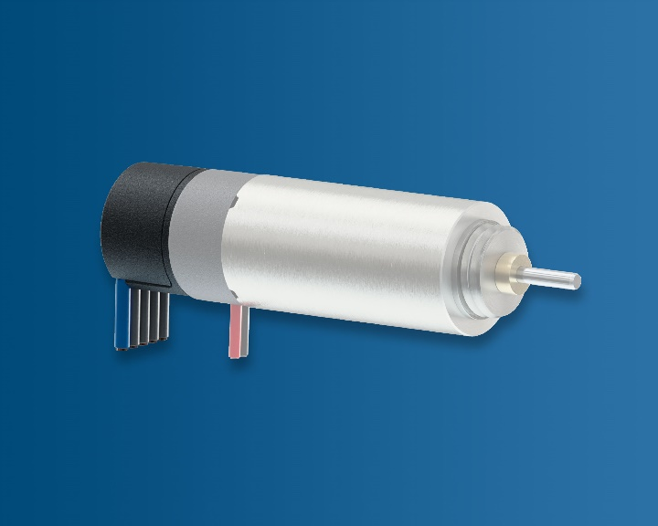 | The IEP3 achieves a very high resolution and accuracy thanks to the latest chip technology. © FAULHABER

Press contact (Germany + International)  Dr. Fritz Faulhaber GmbH & Co. KG  Kristina Wolff – Marketing  Faulhaberstraße 1 · 71101 Schönaich  Germany  T +49 7031 638-148 · F +49 7031 638-8148  redaktion@faulhaber.com | Press contact (Switzerland)  FAULHABER SA  Ann-Kristin Hage-Ripamonti – Marketing  6980 Croglio  Switzerland  T +41 91 61 13 239 · F +41 91 611 31 10  marketing@faulhaber.ch

